August 30, 2023
Ref: IIH/MD/2023/08/009

His Excellency,
The Executive Governor of Kwara State,
Government House,
Ahmadu Bello Way,
GRA, Ilorin, Kwara State

Your Excellency Sir,

KWARA STATE INNOVATION & INFORMATION TECHNOLOGY LAW DRAFT

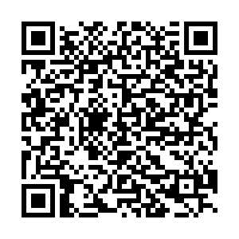
Sequel to your instruction Sir, I write to present the draft of the law to establish the Kwara State Innovation & Information Technology Agency and connected purposes for your approval and further processing. As the completion of the Innovation Hub nears, there is the need to start putting proper operational structure in place. This law is part of the bigger launch plan and strategy for the Ilorin Innovation Hub, to ensure smooth operations and sustainability.

Attached is the full draft of the law itself, which is also available at this QR code.

Yours sincerely,
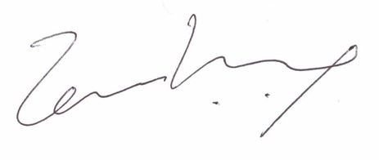
Temi Kolawole
ag. Managing Director

